# Anomaly Detection & Drill Down

* How to on board jobs
  + Anomaly Detection
    - Flow Chart
    - Create recording rule
    - Create Anomaly Detection Job
  + Drill Down
* Rule Group
* Anomaly Detection
  + Job links:
  + Sherlock Dashboard
  + On board status:
    - PL
    - PLA
  + SOP
    - Time Series
    - Job Tuning
    - Alert Rule Configuration
* Drill Down
* Cases

## How to on board jobs

### Anomaly Detection

#### Flow Chart

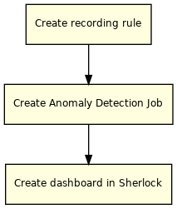

#### Create recording rule

Rule group: [adsshepherd_business_event](https://cloud.ebay.com/rule-groups/rg/adsshepherd_business_event?env=production&ug=ads_infra)

* Refer to the existing recording rules to create new recording rules. Please add **offset 3h** in each metrics to resolve data lag.
* The query format used here is [Grafana LogQL](https://grafana.com/docs/loki/latest/logql/)
* Click the highlighted button in below chart. It will redirect you to the Sherlock dashboard of the recording rule.

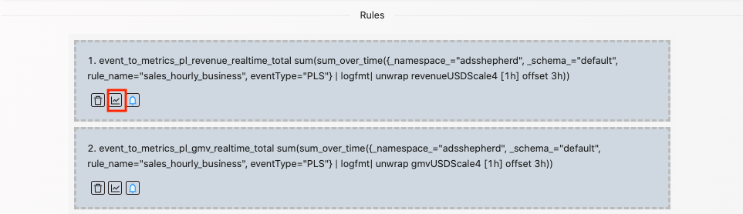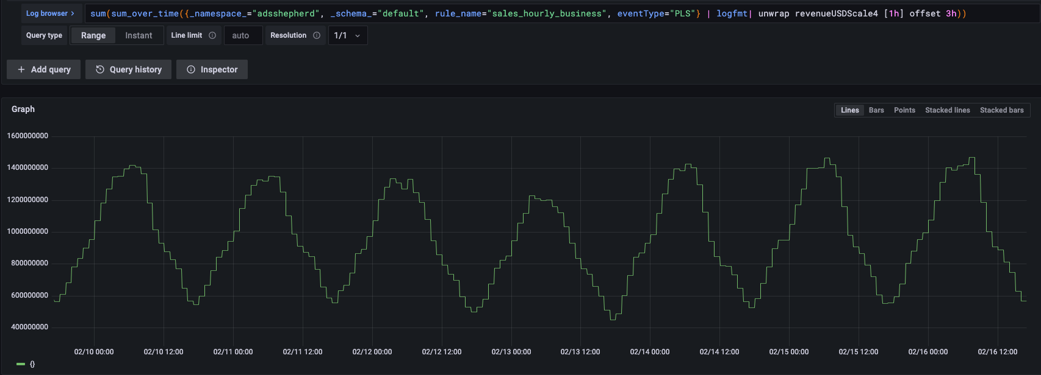

#### Create Anomaly Detection Job

Jobs link: <https://cloud.ebay.com/anomaly/jobslist>

Explore link: <https://cloud.ebay.com/anomaly>

Anomaly Detection Algorithms and Parameters:

* Models including descriptions and formulas
* Parameters <https://pages.github.corp.ebay.com/appmon/shim/parameters/cta.html>

### Drill Down

## Rule Group

Recording Rule: [adsshepherd_business_event](https://cloud.ebay.com/rule-groups/rg/adsshepherd_business_event?env=production&ug=ads_infra)

Note:

**Due to the data lag for business metrics, recoding rule has 3h offset from current time.**

## Anomaly Detection

### Job links:

<https://cloud.ebay.com/anomaly/jobslist> and choose 'adsccoe'(if you are in this dedicated team)  
Alternatively, you may directly go to a certain job by link [https://cloud.ebay.com/anomaly/job/jobdetails/name/<job_name>?isWoodpecker=false](https://cloud.ebay.com/anomaly/job/jobdetails/name/PLGMV_realtime_by_site?isWoodpecker=false)

From alerts' messages in slack channel, you can also find the job link for label **_view_cloudconsole**

### Sherlock Dashboard

Link: <https://console.sherlock.io/d/vO_Rbspnz/anomaly-detection-and-drill-down?orgId=1> (Timezone: MST)

### On board status:

#### PL

|  |  |  |  |  |  |  |  |  |  |
| --- | --- | --- | --- | --- | --- | --- | --- | --- | --- |
| **Job Name** | **Status** | **On Board Date** | **Metrics** | **Dimension** | **Detection Algorithm** | **Alert Rule** | **Slack Channel** | **Pager** | **Replace for** |
| [TotalPLGMV_realtime](https://cloud.ebay.com/anomaly/jobdetails/name/TotalPLGMV_realtime?isWoodpecker=false) | On board |  | GMV | Global | Univariate MEDIFF | [_ad_TotalPLGMV_realtime](https://cloud.ebay.com/rule-groups/rg/_ad_TotalPLGMV_realtime?env=production) | [#ads_p1p2_alerts](https://app.slack.com/client/T0M05TDH6/C02PWMYR54J) |  | pl_global_GMV_drop_WoW |
| [TotalPLRevenue_realtime](https://cloud.ebay.com/anomaly/jobdetails/name/TotalPLRevenue_realtime?isWoodpecker=false) | On board |  | Revenue | Global | Univariate MEDIFF | [_ad_TotalPLRevenue_realtime](https://cloud.ebay.com/rule-groups/rg/_ad_TotalPLRevenue_realtime?env=production) | [#ads_p1p2_alerts](https://app.slack.com/client/T0M05TDH6/C02PWMYR54J) |  | pl_global_revenue_drop_WoW |
| [GlobalPLSoldAdrate_realtime](https://cloud.ebay.com/anomaly/jobdetails/name/GlobalPLSoldAdrate_realtime?isWoodpecker=false) | On board |  | Sold Adrate | Global | Univariate MEDIFF | [_ad_GlobalPLSoldAdrate_realtime](https://cloud.ebay.com/rule-groups/rg/_ad_GlobalPLSoldAdrate_realtime?env=production) | [#ads_p1p2_alerts](https://app.slack.com/client/T0M05TDH6/C02PWMYR54J) |  | pl_global_sold_adrate_drop |
| [TotalPLAttributionRatio_realtime](https://cloud.ebay.com/anomaly/jobdetails/name/TotalPLAttributionRatio_realtime?isWoodpecker=false) | On board |  | Attribution Ratio | Global | Univariate MEDIFF | [_ad_TotalPLAttributionRatio_realtime](https://cloud.ebay.com/rule-groups/rg/_ad_TotalPLAttributionRatio_realtime?env=production) | [#ads_p1p2_alerts](https://app.slack.com/client/T0M05TDH6/C02PWMYR54J) |  | pl_global_ATTR_RATE_drop_WoW |
| [PLGMV_realtime_by_site](https://cloud.ebay.com/anomaly/jobdetails/name/PLGMV_realtime_by_site?isWoodpecker=false) | On board |  | GMV | By Site  US, UK, DE, AU, AUTOS |  | [_ad_PLGMV_realtime_by_top_site](https://cloud.ebay.com/rule-groups/rg/_ad_PLGMV_realtime_by_top_site?env=production) | [#ads_p1p2_alerts](https://app.slack.com/client/T0M05TDH6/C02PWMYR54J) |  | [PLGMV_realtime_by_site](https://cloud.ebay.com/anomaly/jobdetails/name/PLGMV_realtime_by_site?isWoodpecker=false) - Top sites US, UK, DE, AU, AUTOS |
| → [PLGMV_realtime_by_site](https://cloud.ebay.com/anomaly/jobdetails/name/PLGMV_realtime_by_site?isWoodpecker=false) | On board |  | GMV | By Site |  | [_ad_PLGMV_realtime_by_site](https://cloud.ebay.com/rule-groups/rg/_ad_PLGMV_realtime_by_site?env=production) | [#ads_p3p4_alerts](https://app.slack.com/client/T0M05TDH6/C02PWMYR54J) |  | pl_GMV_drop_by_site_WoW |
| [PLRevenue_realtime_by_site](https://cloud.ebay.com/anomaly/jobdetails/name/PLRevenue_realtime_by_site?isWoodpecker=false) | On board |  | Revenue | By Site |  | [_ad_PLRevenue_realtime_by_site](https://cloud.ebay.com/rule-groups/rg/_ad_PLRevenue_realtime_by_site?env=production) | [#ads_p1p2_alerts](https://app.slack.com/client/T0M05TDH6/C02PWMYR54J) |  | pl_revenue_drop_by_site_WoW |
| [PLSoldAdrate_realtime_by_site](https://cloud.ebay.com/anomaly/jobdetails/name/PLSoldAdrate_realtime_by_site?isWoodpecker=false) | On board |  | Sold Adrate | By Site |  | [_ad_PLSoldAdrate_realtime_by_site](https://cloud.ebay.com/rule-groups/rg/_ad_PLSoldAdrate_realtime_by_site?env=production) | [#ads_p1p2_alerts](https://app.slack.com/client/T0M05TDH6/C02PWMYR54J) |  |  |
| [PLAttributionRatio_realtime_by_site](https://cloud.ebay.com/anomaly/jobdetails/name/PLAttributionRatio_realtime_by_site?isWoodpecker=false) | On board |  | Attribution Ratio | By Site |  | [_ad_PLAttributionRatio_realtime_by_site](https://cloud.ebay.com/rule-groups/rg/_ad_PLAttributionRatio_realtime_by_site?env=production) | [#ads_p1p2_alerts](https://app.slack.com/client/T0M05TDH6/C02PWMYR54J) |  |  |
| [PLRevenue_realtime_by_pageFamily](https://cloud.ebay.com/anomaly/job/jobdetails/name/PLRevenue_realtime_by_pageFamily?isWoodpecker=false) | On board |  | Revenue | By Page Family |  | [_ad_PLRevenue_realtime_by_pageFamily](https://cloud.ebay.com/rule-groups/rg/_ad_PLRevenue_realtime_by_pageFamily?env=production) | [#ads_p1p2_alerts](https://app.slack.com/client/T0M05TDH6/C02PWMYR54J) |  | pl_merch_revenue_drop_WoW, pl_srp_revenue_drop_WoW, pl_offebay_revenue_drop_WoW |
| [PLGMV_realtime_by_pageFamily](https://cloud.ebay.com/anomaly/job/jobdetails/name/PLGMV_realtime_by_pageFamily?isWoodpecker=false) | On board |  | GMV | By Page Family |  | [_ad_PLGMV_realtime_by_pageFamily](https://cloud.ebay.com/rule-groups/rg/_ad_PLGMV_realtime_by_pageFamily?env=production) | [#ads_p1p2_alerts](https://app.slack.com/client/T0M05TDH6/C02PWMYR54J) |  | pl_merch_GMV_drop_WoW, pl_srp_GMV_drop_WoW, pl_offebay_GMV_drop_WoW |
| [PLSoldAdrate_realtime_by_pageFamily](https://cloud.ebay.com/anomaly/job/jobdetails/name/PLSoldAdrate_realtime_by_pageFamily?isWoodpecker=false) | On board |  | Sold Adrate | By Page Family |  | [_ad_PLSoldAdrate_realtime_by_pageFamily](https://cloud.ebay.com/rule-groups/rg/_ad_PLSoldAdrate_realtime_by_pageFamily?env=production) | [#ads_p1p2_alerts](https://app.slack.com/client/T0M05TDH6/C02PWMYR54J) |  |  |
| [PLRevenue_realtime_dWeb](https://cloud.ebay.com/anomaly/job/jobdetails/name/PLRevenue_realtime_dWeb?isWoodpecker=false) | On board | Mar 8 2022 | Revenue | dWeb |  | [_ad_PLRevenue_realtime_dWeb](https://cloud.ebay.com/rule-groups/rg/_ad_PLRevenue_realtime_dWeb?env=production) | [#ads_p1p2_alerts](https://app.slack.com/client/T0M05TDH6/C02PWMYR54J) |  | pl_dWeb_revenue_drop_WoW |
| [PLRevenue_realtime_mWeb](https://cloud.ebay.com/anomaly/job/jobdetails/name/PLRevenue_realtime_mWeb?isWoodpecker=false) | On board | Mar 8 2022 | Revenue | mWeb |  | [_ad_PLRevenue_realtime_mWeb](https://cloud.ebay.com/rule-groups/rg/_ad_PLRevenue_realtime_mWeb?env=production) | [#ads_p1p2_alerts](https://app.slack.com/client/T0M05TDH6/C02PWMYR54J) |  | pl_mWeb_revenue_drop_WoW |
| [PLRevenue_realtime_device_other](https://cloud.ebay.com/anomaly/job/jobdetails/name/PLRevenue_realtime_device_other?isWoodpecker=false) | On board | Mar 8 2022 | Revenue | other |  | [_ad_PLRevenue_realtime_device_other](https://cloud.ebay.com/rule-groups/rg/_ad_PLRevenue_realtime_device_other?env=production) | [#ads_p1p2_alerts](https://app.slack.com/client/T0M05TDH6/C02PWMYR54J) |  |  |
| [PLGMV_realtime_dWeb](https://cloud.ebay.com/anomaly/job/jobdetails/name/PLGMV_realtime_dWeb?isWoodpecker=false) | On board | Mar 8 2022 | GMV | dWeb |  | [_ad_PLGMV_realtime_dWeb](https://cloud.ebay.com/rule-groups/rg/_ad_PLGMV_realtime_dWeb?env=production) | [#ads_p1p2_alerts](https://app.slack.com/client/T0M05TDH6/C02PWMYR54J) |  | pl_dWeb_GMV_drop_WoW |
| [PLGMV_realtime_mWeb](https://cloud.ebay.com/anomaly/job/jobdetails/name/PLGMV_realtime_mWeb?isWoodpecker=false) | On board | Mar 8 2022 | GMV | mWeb |  | [_ad_PLGMV_realtime_mWeb](https://cloud.ebay.com/rule-groups/rg/_ad_PLGMV_realtime_mWeb?env=production) | [#ads_p1p2_alerts](https://app.slack.com/client/T0M05TDH6/C02PWMYR54J) |  | pl_mWeb_GMV_drop_WoW |
| [PLGMV_realtime_device_other](https://cloud.ebay.com/anomaly/job/jobdetails/name/PLGMV_realtime_device_other?isWoodpecker=false) | On board | Mar 8 2022 | GMV | other |  | [_ad_PLGMV_realtime_device_other](https://cloud.ebay.com/rule-groups/rg/_ad_PLGMV_realtime_device_other?env=production) | [#ads_p1p2_alerts](https://app.slack.com/client/T0M05TDH6/C02PWMYR54J) |  |  |
| [PLSoldAdrate_realtime_dWeb](https://cloud.ebay.com/anomaly/job/jobdetails/name/PLSoldAdrate_realtime_dWeb?isWoodpecker=false) | On board | Mar 8 2022 | Sold Adrate | dWeb |  | [_ad_PLSoldAdrate_realtime_dWeb](https://cloud.ebay.com/rule-groups/rg/_ad_PLSoldAdrate_realtime_dWeb?env=production) | [#ads_p1p2_alerts](https://app.slack.com/client/T0M05TDH6/C02PWMYR54J) |  |  |
| [PLSoldAdrate_realtime_mWeb](https://cloud.ebay.com/anomaly/job/jobdetails/name/PLSoldAdrate_realtime_mWeb?isWoodpecker=false) | On board | Mar 8 2022 | Sold Adrate | mWeb |  | [_ad_PLSoldAdrate_realtime_mWeb](https://cloud.ebay.com/rule-groups/rg/_ad_PLSoldAdrate_realtime_mWeb?env=production) | [#ads_p1p2_alerts](https://app.slack.com/client/T0M05TDH6/C02PWMYR54J) |  |  |
| [PLSoldAdrate_realtime_device_other](https://cloud.ebay.com/anomaly/job/jobdetails/name/PLSoldAdrate_realtime_device_other?isWoodpecker=false) | Tuning | Mar 14 2022 | Sold Adrate | other |  | [_ad_PLSoldAdrate_realtime_device_other](https://cloud.ebay.com/rule-groups/rg/_ad_PLSoldAdrate_realtime_device_other?env=production) | [#ads_p1p2_alerts](https://app.slack.com/client/T0M05TDH6/C02PWMYR54J) |  |  |

Note: rules in Replace for column are not disabled and they have  more tolerant thresholds

Please don't change: **_ad_...** are generated by anomaly detection.

#### PLA

|  |  |  |  |  |  |  |  |  |
| --- | --- | --- | --- | --- | --- | --- | --- | --- |
| **Job Name** | **Status** | **On Board Date** | **Metrics** | **Dimension** | **Alert Rule** | **Slack Channel** | **Pager** | **Replace for** |
| [TotalPLAGMV_realtime](https://cloud.ebay.com/anomaly/jobdetails/name/TotalPLAGMV_realtime?isWoodpecker=false) | On board |  | GMV | Global | [_ad_TotalPLAGMV_realtime](https://cloud.ebay.com/rule-groups/rg/_ad_TotalPLAGMV_realtime?env=production) | [#ads_p1p2_alerts](https://app.slack.com/client/T0M05TDH6/C02PWMYR54J) |  | pla_global_GMV_drop_WoW |
| [TotalPLARevenue_realtime](https://cloud.ebay.com/anomaly/jobdetails/name/TotalPLARevenue_realtime?isWoodpecker=false) | On board |  | Revenue | Global | [_ad_TotalPLARevenue_realtime](https://cloud.ebay.com/rule-groups/rg/_ad_TotalPLARevenue_realtime?env=production) | [#ads_p1p2_alerts](https://app.slack.com/client/T0M05TDH6/C02PWMYR54J) |  | pla_global_revenue_drop_WoW |
| [PLAGMV_realtime_by_site](https://cloud.ebay.com/anomaly/jobdetails/name/PLAGMV_realtime_by_site?isWoodpecker=false) | On board |  | GMV | By Site | [_ad_PLAGMV_realtime_by_site](https://cloud.ebay.com/rule-groups/rg/_ad_PLAGMV_realtime_by_site?env=production) | [#ads_p1p2_alerts](https://app.slack.com/client/T0M05TDH6/C02PWMYR54J) |  | pla_GMV_drop_by_site_WoW |
| [PLARevenue_realtime_by_site](https://cloud.ebay.com/anomaly/jobdetails/name/PLARevenue_realtime_by_site?isWoodpecker=false) | On board |  | Revenue | By Site | [_ad_PLARevenue_realtime_by_site](https://cloud.ebay.com/rule-groups/rg/_ad_PLARevenue_realtime_by_site?env=production) | [#ads_p1p2_alerts](https://app.slack.com/client/T0M05TDH6/C02PWMYR54J) |  | pla_revenue_drop_by_site_WoW |
|  |  |  |  |  |  |  |  |  |
|  |  |  |  |  |  |  |  |  |

### SOP

#### Time Series

Note: **Due to the data lag for business metrics, recoding rule has 3h offset from current time.**

#### Job Tuning

#### Alert Rule Configuration

## Drill Down

## Cases

